# Factory loader using other UART interfaces

## Connecting INP101x using UART

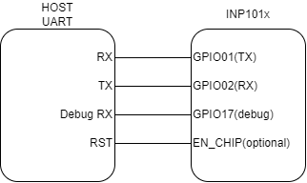

Figure 6 Connecting to other UART interfaces

## Programming using UART

|  |
| --- |
| ./script/factory_loader.py /dev/ttyUSB2 helloworld_config.json |